FAZAIA BILQUIS COLLEGE NUR KHAN BASE RAWALPINDI



Submitted By:
Tasmia Fatima
BSCS-13-F24-49
Maria Atta
BSCS-13-F24-01

Submitted To:
Dr. Inam Ullah Khan

Table of Contents:
- Abstraction ----------------------------------------- Page # 03
- Introduction ---------------------------------------- Page # 03
- Problem Statement ------------------------------ Page # 03
- Objectives ------------------------------------------- Page # 04
- System Design ------------------------------------- Page # 04
  - System Architecture ---------------------- Page # 04
  - HoneyTrap Mechanism ------------------ Page # 05
- Implementation Details ------------------------ Page # 05
  - Login and Risk Scoring ------------------ Page # 06
  - Public Pages ---------------------------------- Page # 06
  - Monitoring and Alerts -------------------- Page # 06
- Key Features ---------------------------------------- Page # 06
- Technologies Used ------------------------------- Page # 06
- Advantages ------------------------------------------ Page # 07
- Limitations ------------------------------------------ Page # 07
- Algorithms Used --------------------------- Page # 07
- Results/Outputs ---------------------------- Page # 07
- Testing ----------------------------------------- Page # 11
- Feature Enhancements ------------------ Page # 11
- Conclusion ----------------------------------- Page # 11
- References ------------------------------------ Page # 11

Abstract
In the digital age, websites are under constant threat from hackers who attempt to access sensitive information using a variety of techniques. Traditional security measures, such as firewalls, can block attackers but do not provide insight into their methods. The Sentinel Cyber Defense System is designed as an advanced security solution that combines a professional website with a Honeytrap mechanism. The Honeytrap acts as a decoy, luring suspicious users into a fake environment where all their actions are recorded for analysis. This system provides both protection and intelligence, allowing administrators to study attacker behavior and strengthen security measures proactively.

1. Introduction
- Cybersecurity has become a critical concern for websites and online applications. Conventional methods, such as firewalls and antivirus tools, are reactive—they block attacks but do not capture the details of intrusions.
- The Sentinel Cyber Defense System goes beyond these tools by introducing a Honeytrap mechanism. A Honeytrap is essentially a fake environment or a decoy designed to attract attackers. When a hacker attempts to breach the system, they are redirected to the Honeytrap, which records their activities without their knowledge.
- This project serves both as a security solution and an educational demonstration, showing how modern cybersecurity techniques can combine prevention and intelligence-gathering.

2. Problem Statement
Despite advances in cybersecurity, websites remain vulnerable to the following issues:
- Clever Attackers: Hackers often use sophisticated tools to guess passwords, exploit vulnerabilities, or inject malicious code (e.g., SQL Injection).
- Invisible Attacks: Many intrusions go undetected until significant damage occurs.
- Lack of Insight: Traditional systems block attackers but do not analyze their behavior, limiting the ability to anticipate future attacks.
The Sentinel Cyber Defense System addresses these problems by actively studying suspicious behavior and protecting real user data through a decoy environment.

3. Objectives
The primary objectives of this project are:
- To create a secure web system that can detect and trap suspicious users.
- To log and analyze hacker activity in a controlled environment.
- To implement a risk scoring system that evaluates login attempts based on behavior.
- To provide a professional web interface that simulates a real business environment.
- To demonstrate practical cybersecurity techniques for academic and educational purposes.

4. System Design
4.1 System Architecture
The system is divided into three layers:
- Frontend (User Interface):
  - Designed using HTML, CSS, and Bootstrap.
  - Provides pages for login, admin dashboard, careers, and news.
- Backend (Business Logic):
  - Implemented in PHP.
  - Handles login authentication, risk scoring, and Honeytrap redirection.
- Database (Data Storage):
  - MySQL database stores user credentials, job applications, and action logs.
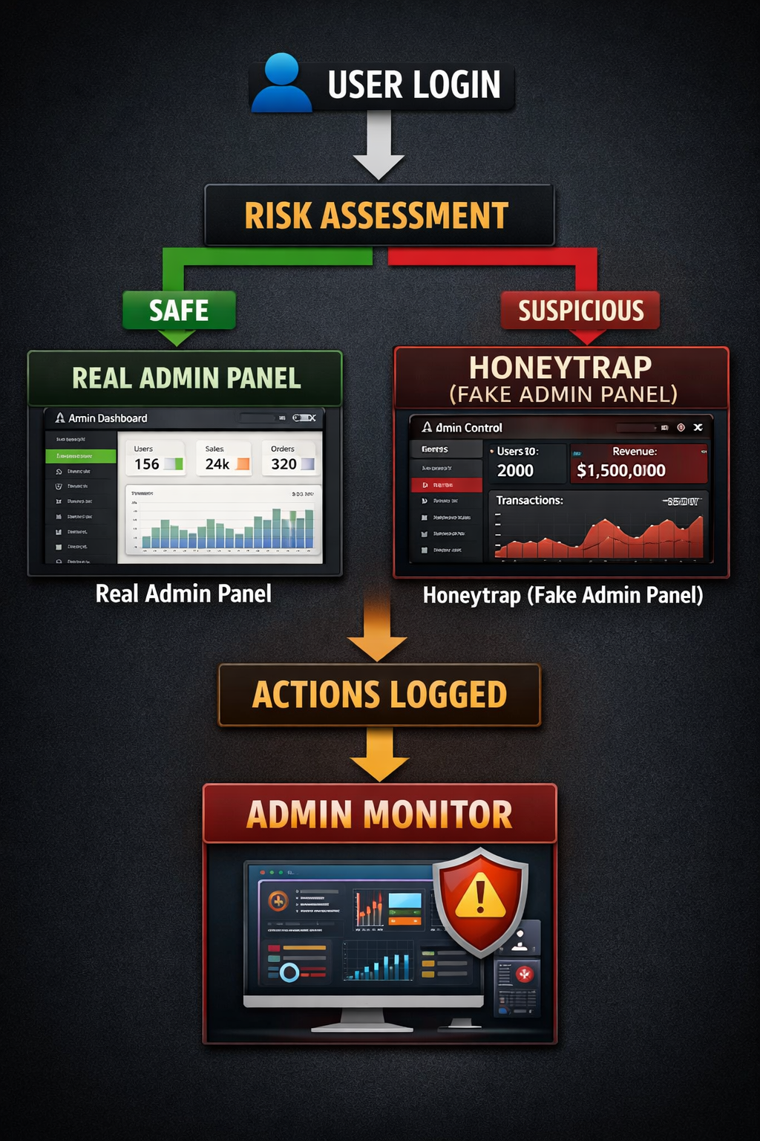
Flow Diagram:

4.2 Honeytrap Mechanism
The Honeytrap is a decoy system designed to trap malicious users. Features include:
- Fake Admin Dashboard: Appears identical to the real panel but contains no real data.
- Action Logger: Tracks clicks, keystrokes, and navigation patterns.
- Confusion Module: Buttons show fake errors or delays to mislead attackers.
- Live Monitoring: Real admins can view all activity in real-time and categorize users by risk.

5. Implementation Details
5.1 Login & Risk Scoring
- Users are assigned a risk score (0–100) based on login behavior.
- Suspicious patterns (e.g., SQL injection strings, multiple failed attempts) increase the score.
- High-risk users are redirected to the Honeytrap automatically.
5.2 Public Pages
- Careers Page: Secure form for job applications.
- News Page: Articles on cybersecurity topics (IoT Botnets, phishing) with images.
5.3 Monitoring & Alerts
- Admin dashboard displays:
  - Green: Safe users
  - Red: Blocked users
  - Orange: Users inside Honeytrap

6. Scope and Limitations
- Smart Login: Monitors login behavior beyond password checks.
- Honeytrap: Captures attacker behavior in a controlled environment.
- Live Threat Feed: Real-time visualization of user activity.
- Public Pages: Careers and news feed to simulate a professional website.
- Action Logging: Every click and keystroke is recorded.

7. Technologies Used
Component | Technology | Purpose
Frontend | HTML, CSS, Bootstrap | Responsive and professional UI
Backend | PHP | Handles logic, login, and Honeytrap operations
Database | MySQL | Stores users, logs, applications
JavaScript | JS | Interactive elements, popups, action tracking

8. Advantages
- Proactively detects and traps malicious users.
- Captures detailed attacker behavior for analysis.
- Provides a professional-looking website to hide security mechanisms.
- Educates about practical cybersecurity implementations.

9. Limitations
- No multi-factor authentication yet.
- Limited analytics and reporting for admins.
- Currently designed for demonstration/educational purposes rather than enterprise deployment.

10. Algorithms Used
Mention:
- Risk scoring algorithm (based on login behavior)
- Redirection logic (if-else based on score)
- Logging and monitoring logic

11. Results / Output
- Login page
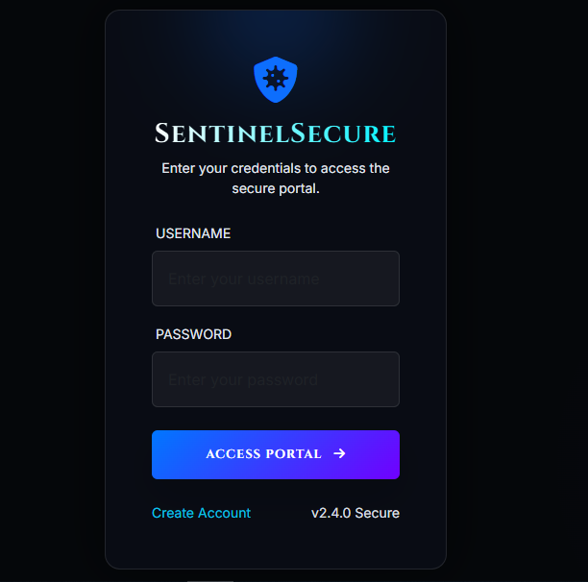
- Admin dashboard

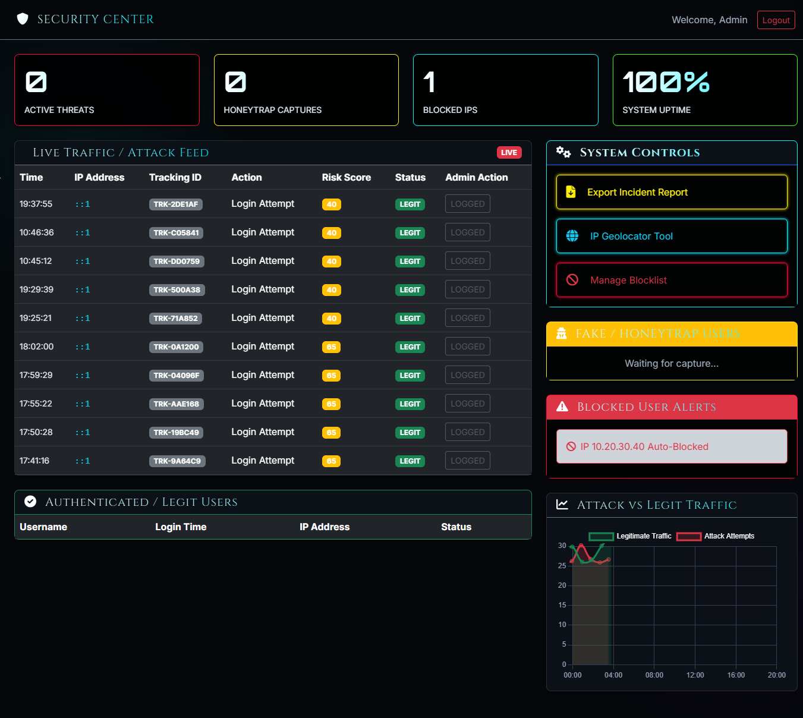
- Honeytrap interface

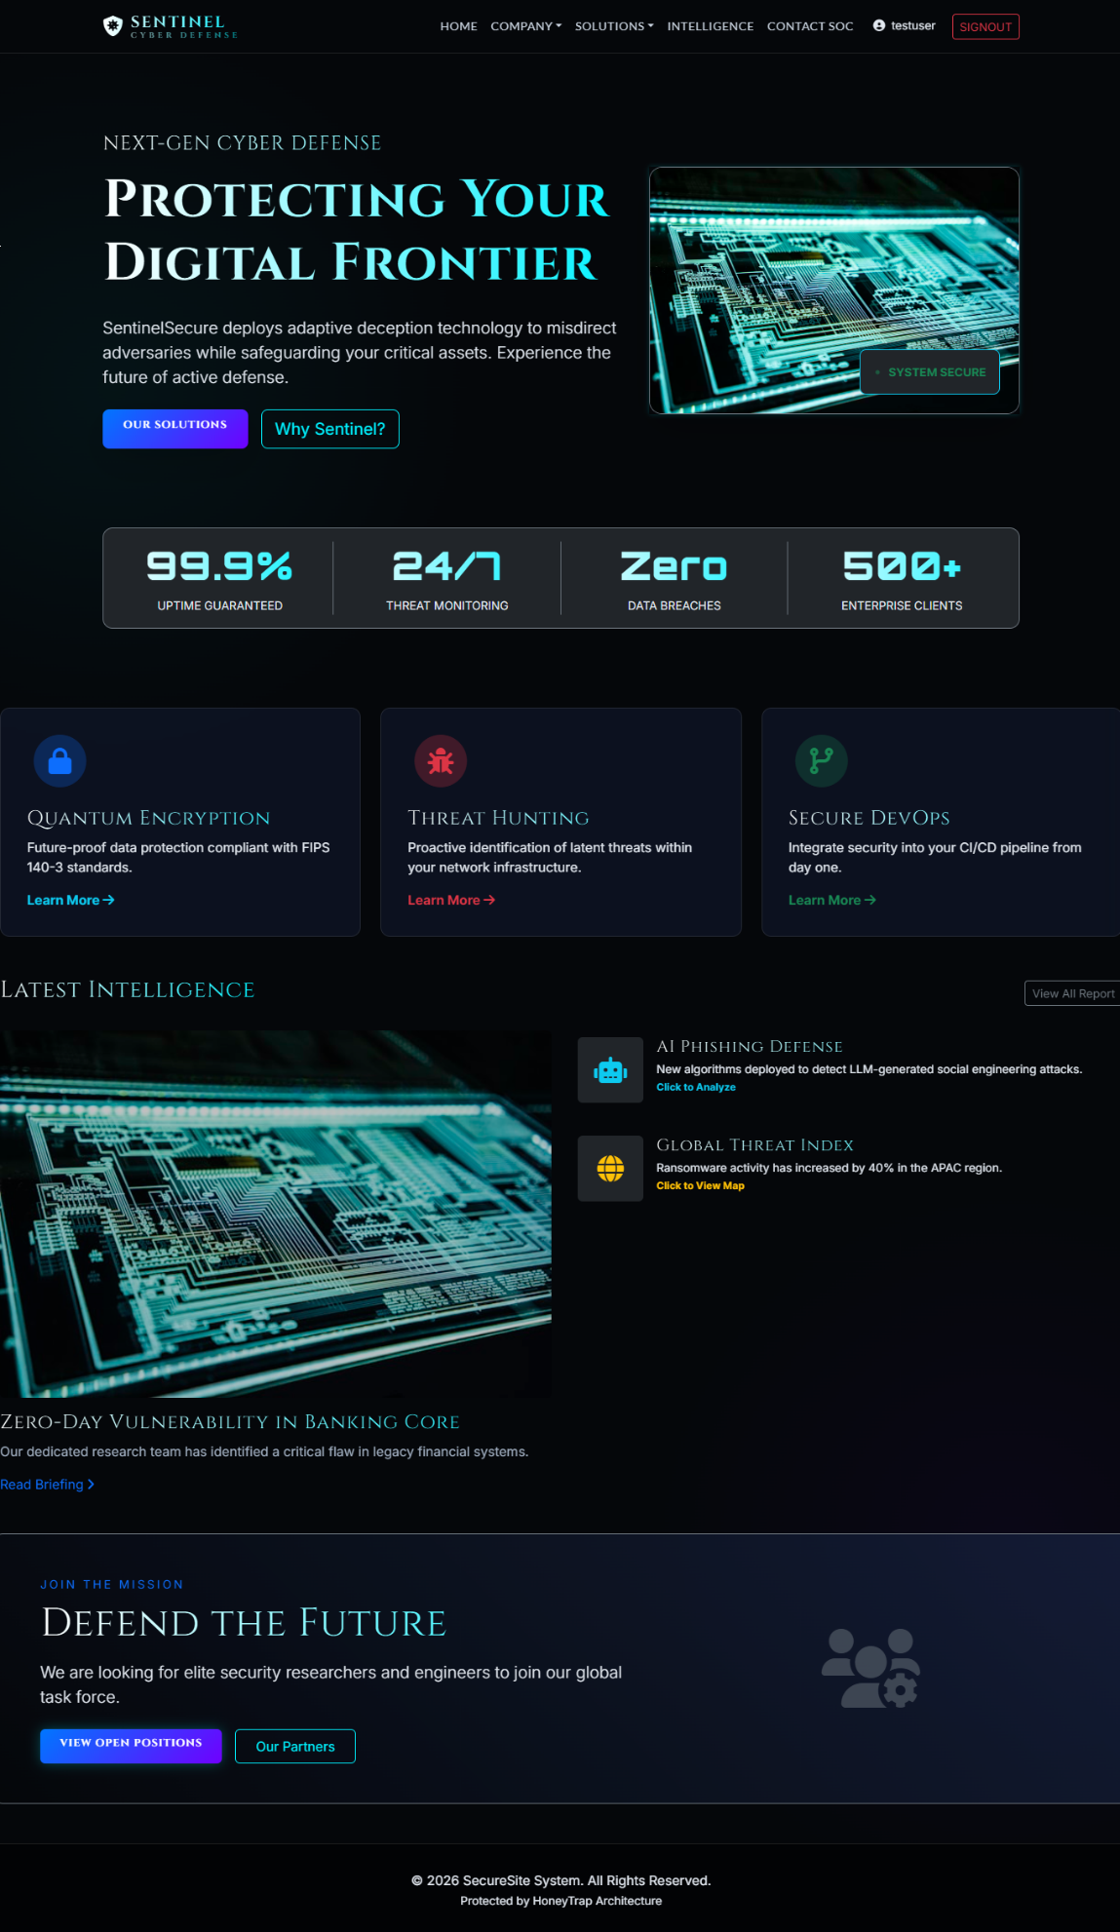
13. Testing
Test Case | Input | Expected Output | Actual Output | Status
Normal login | Valid credentials | Access granted | ✅ | Pass
SQL injection | ‘ OR ‘1’=’1 | Redirect to Honeytrap | ✅ | Pass
Multiple failed attempts | Wrong password x5 | Account locked / redirected | ✅ | Pass
Admin login | Admin credentials | Access to real dashboard | ✅ | Pass

14. Future Enhancements
- Implement multi-factor authentication for admins.
- Enhance analytics dashboard with charts and alerts.
- Make system mobile-friendly.
- Integrate with external security monitoring tools.
- Automate risk assessment using AI algorithms.

11. Conclusion
The Sentinel Cyber Defense System is an advanced cybersecurity solution combining a professional website with a hidden Honeytrap. It allows administrators to proactively protect data, monitor suspicious activity, and study attacker behavior in a safe environment. This project demonstrates practical cybersecurity techniques, providing both protection and educational value.
12. References
- PHP Documentation – https://www.php.net/
- MySQL Documentation – https://dev.mysql.com/doc/
- HTML & CSS Reference – https://developer.mozilla.org/
- Cybersecurity Articles: IoT Botnets, SQL Injection Techniques

